FDS LAB QUESTIONS

NAME : DIVYA.K

DATE : 03.10.2024

REGISTER NO : 230701082

**Exp No:4** To Count the frequency of occurrence of a word in a body of text is often needed during text processing.

**Description**: Import the word_tokenize function and gutenberg.

CODE :

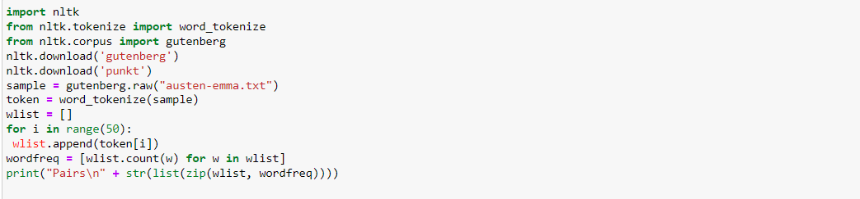

OUTPUT :

